SIMATS ENGINEERING
ECA08 – ANALOG AND DIGITAL COMMUNICATION
CO2 CASE STUDY ASSIGNMENT
FM Broadcast System: From Angle-Modulation Selection to Noise-Performance Deployment
Submitted by: PRAGADEESH .I
Register Number: 192512198
Department: Electronics and Communication Engineering
Course Outcome: CO2

ABSTRACT
This report develops a practical FM broadcast design for a regional station. The given requirements specify a 15 kHz maximum audio frequency, a 100 MHz candidate carrier and an initial peak frequency deviation of 75 kHz. FM is selected because it keeps the ideal transmitted envelope constant and can provide good noise performance when the received carrier-to-noise ratio is sufficiently high. Carson’s rule gives an estimated transmission bandwidth of 180 kHz for the stated maximum audio frequency and deviation. The report compares FM with PM, AM and DSB-SC, presents transmitter and receiver architectures, discusses noise and pre-emphasis/de-emphasis, and provides illustrative plots to show expected signal behaviour. Numerical noise curves are explanatory examples, not measurements from a physical receiver.

1. CASE STUDY REQUIREMENTS AND ASSUMPTIONS
The design is based on the assignment brief. The station must provide reliable recovered audio while balancing spectrum use, noise performance, power and implementation complexity.
- Maximum message frequency, fm(max) = 15 kHz
- Candidate carrier frequency, fc = 100 MHz
- Initial peak frequency deviation, Δf = 75 kHz
- Channel: additive white Gaussian noise (AWGN) plus practical interference and receiver limitations
- Receiver: limiter followed by a frequency discriminator
- Noise improvement to evaluate: pre-emphasis and de-emphasis
- Analysis platform: MATLAB
Assumptions: ideal angle modulation has constant envelope; Carson’s rule is used for a practical bandwidth estimate; a 75 μs de-emphasis time constant is used only as an illustrative broadcast example and should be checked against the applicable local standard. No transmitter power, required SNR or minimum C/N is specified, so these cannot be uniquely calculated from the brief.

2. BASIC COMMUNICATION SYSTEM
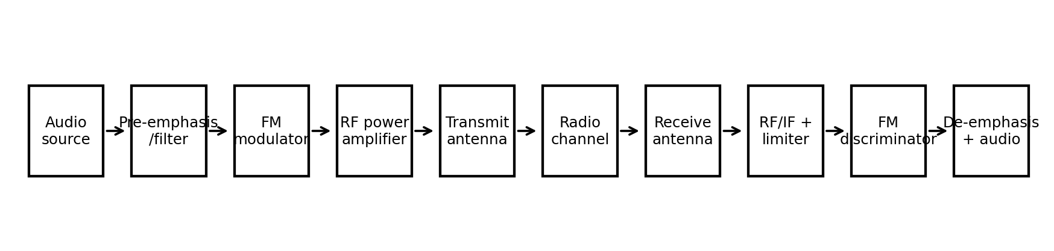
Figure 1. Basic FM broadcast communication chain.
The audio signal is conditioned and pre-emphasized before FM modulation. The RF stage raises the signal to the required transmit level and the antenna radiates it. The channel adds noise and interference. At the receiver, RF/IF filtering selects the wanted station, the limiter reduces amplitude variations, and the discriminator converts frequency variations back to audio. De-emphasis then reduces the high-frequency noise boost introduced by pre-emphasis.

2.1 Why modulation is required
Directly transmitting low-frequency audio is inefficient for practical radio coverage because an antenna suitable for low-frequency signals would be very large, radiation efficiency is poor, and many users could not share a channel conveniently. Modulation shifts the information onto a high-frequency carrier, supports practical antennas and enables channel allocation and filtering.

2.2 Angle modulation: FM and PM
In angle modulation, the carrier amplitude ideally remains constant while its angle changes with the message. In frequency modulation (FM), instantaneous frequency varies in proportion to the message. In phase modulation (PM), instantaneous phase varies in proportion to the message. Since frequency is the derivative of phase, FM and PM are related but their deviation depends differently on the message and its derivative.
For a sinusoidal message m(t) = Am cos(2πfmt), FM can be written as sFM(t) = Ac cos[2πfct + β sin(2πfmt)], where β = Δf/fm. The instantaneous frequency is fi(t) = fc + Δf cos(2πfmt). For PM, sPM(t) = Ac cos[2πfct + kp m(t)], where kp is phase sensitivity in radians per unit amplitude.

3. FM MODULATION INDEX AND BANDWIDTH
Using the maximum message frequency and initial deviation: β = Δf/fm(max) = 75 kHz / 15 kHz = 5. The modulation index is therefore 5 at the maximum audio frequency, which is wideband FM (WBFM) under the usual classification. For a lower message frequency, the index would be larger if deviation remained fixed.
Carson’s rule: BT ≈ 2(Δf + fm(max)) = 2(75 kHz + 15 kHz) = 180 kHz. This is an engineering estimate of the bandwidth containing most of the significant FM sideband power, not an exact hard spectral boundary. Actual occupied bandwidth and permitted deviation must be checked against the applicable broadcast regulations and channel plan.
An FM signal contains a carrier component and sidebands at fc ± n fm. Their amplitudes are governed by Bessel functions Jn(β). As β increases, more sidebands become significant and the occupied bandwidth generally grows. Excessive deviation can cause adjacent-channel interference. Ideal FM does not change its envelope amplitude, so ideal average transmitted power is constant; practical amplifiers and filters still introduce limits.
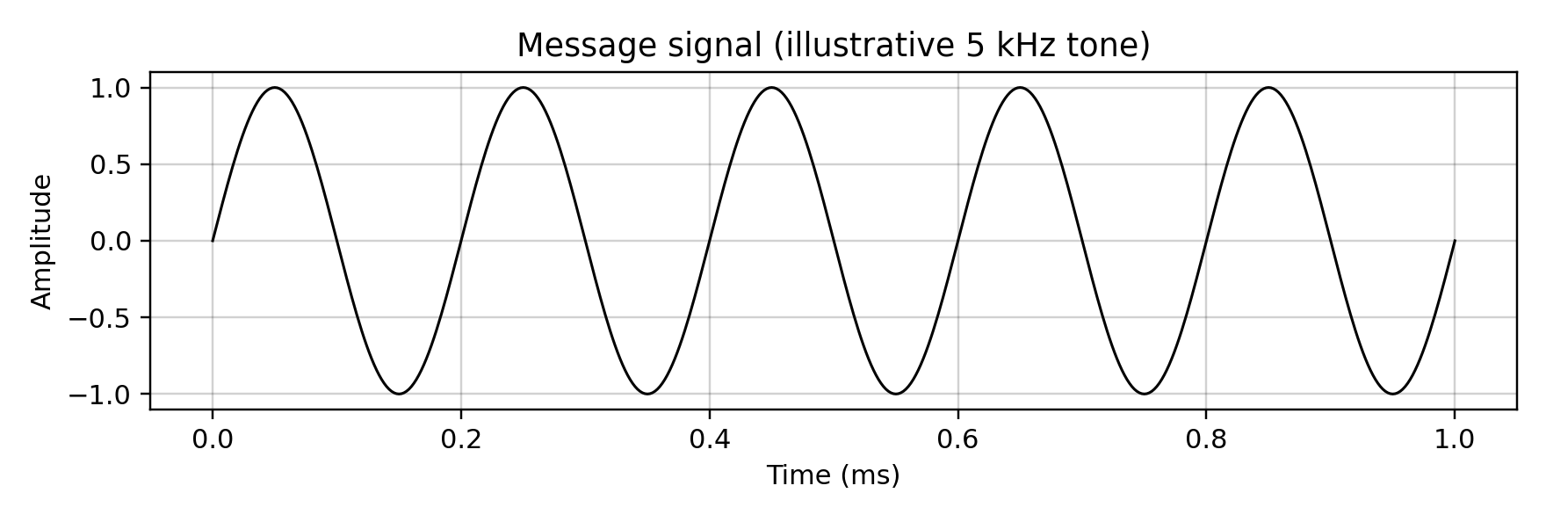
Figure 2. Illustrative sinusoidal message signal.
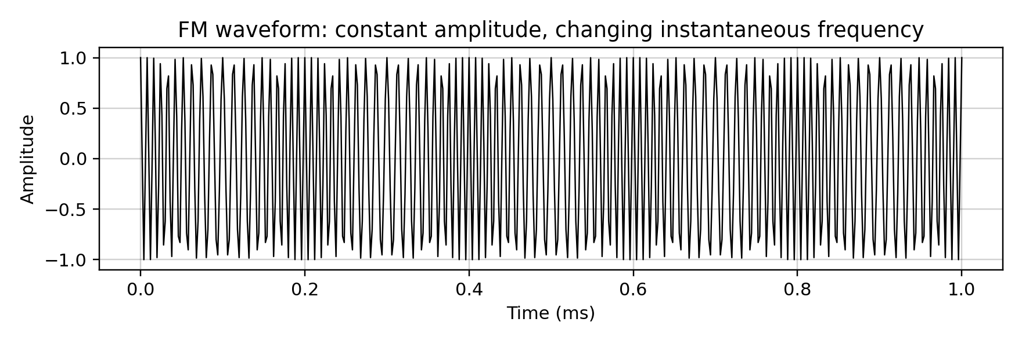
Figure 3. Illustrative FM waveform showing changing cycle spacing.
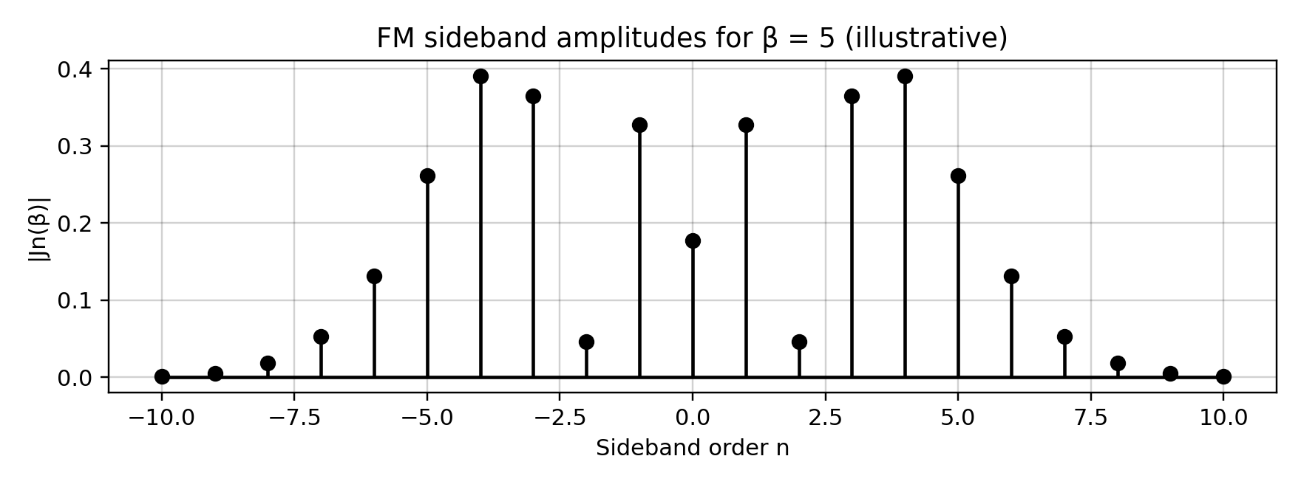
Figure 4. Bessel sideband amplitudes for β = 5; lines are illustrative of a 5 kHz single-tone example.

4. FM AND PM COMPARISON
Feature | FM | PM
What varies | Instantaneous frequency | Instantaneous phase
Message relation | Frequency deviation follows message amplitude | Phase deviation follows message amplitude
Single-tone index | β = Δf/fm | Phase index = kp Am
Bandwidth | Depends on deviation and message frequency; Carson’s rule is common | Depends on phase index and message frequency
Detection | Frequency discriminator or PLL | Phase detector or suitable derivative-based method
Power | Constant envelope ideally | Constant envelope ideally
Practical note | Common for broadcast audio; limiter helps reject amplitude noise | Can be generated directly or derived from FM/PM modulation methods
Decision 1: use FM for the proposed broadcast chain. It matches the specified limiter-discriminator receiver and is a familiar way to obtain robust audio service. PM remains a valid angle-modulation technique, but it is not selected because the brief already specifies an FM receiver arrangement.

5. TRANSMITTER AND RECEIVER ARCHITECTURE

5.1 Transmitter
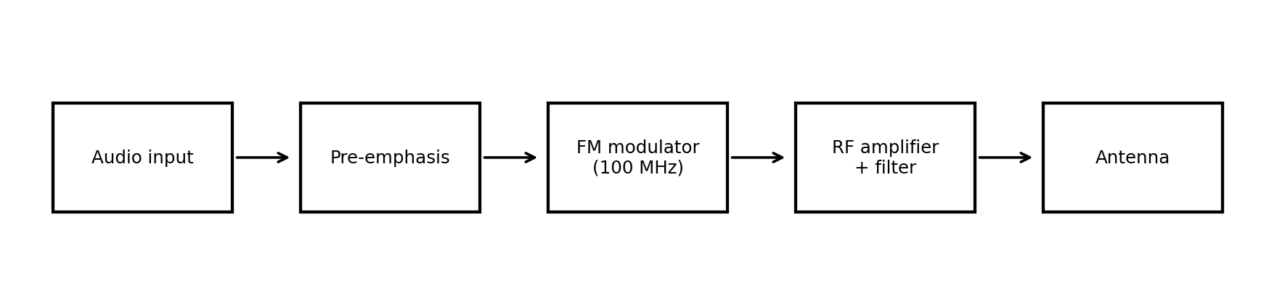
Figure 5. Proposed FM transmitter block diagram.
The audio input is filtered to limit the maximum message frequency to 15 kHz. Pre-emphasis raises higher audio frequencies before modulation. The FM modulator produces the 100 MHz carrier with controlled peak deviation. A linear or suitably operated RF power stage and output filter feed the antenna. Frequency stability and deviation control are important to maintain the channel assignment and avoid excess adjacent-channel energy.

5.2 Receiver
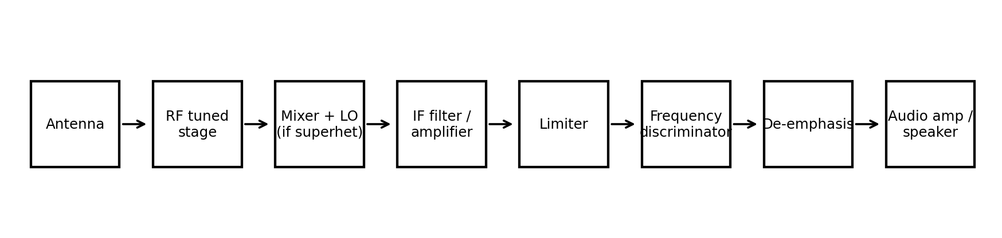
Figure 6. Superheterodyne-style FM receiver block diagram.
The tuned RF stage provides sensitivity and image/interference rejection. A mixer and local oscillator translate the selected station to an intermediate frequency (IF), where filtering and amplification provide selectivity. The limiter reduces amplitude fluctuations before the discriminator. The discriminator converts instantaneous frequency changes to a voltage waveform; de-emphasis restores the intended audio response and reduces high-frequency noise. A direct-conversion or integrated FM receiver may use a different internal arrangement, but the same functional operations remain.

5.3 Key receiver parameters
- Sensitivity: the minimum input level that produces acceptable audio quality.
- Selectivity: ability to reject nearby channels and unwanted signals.
- Fidelity: how accurately the recovered audio follows the original audio.
- Frequency stability: keeps tuning and demodulation aligned with the station.
- Adjacent-channel rejection: depends on RF/IF filtering, channel spacing and compliant deviation.
- Limiter: suppresses amplitude variation before FM detection; it cannot remove all noise or overcome a weak-signal threshold.
- Discriminator: converts frequency deviation into a proportional baseband output over its linear operating range.

6. AM AND DSB-SC NOISE PERFORMANCE
For a fair comparison, assume the same message power, receiver noise bandwidth and AWGN power spectral density. The exact output SNR depends on modulation depth, carrier-to-noise ratio, detector type and the chosen normalization. Therefore, the assignment data alone do not produce one unique numeric AM or DSB-SC output SNR.
For conventional AM with modulation index μ (0 ≤ μ ≤ 1) and a single-tone message, the sideband power is related to carrier power by Psidebands = (μ²/2)Pc. The carrier itself carries no message, so conventional AM spends power on the carrier. An envelope detector is simple but needs a sufficiently strong carrier and suitable modulation conditions.
DSB-SC suppresses the carrier and places information in the two sidebands, improving carrier-power efficiency. It normally requires coherent (product) detection and synchronization of the receiver oscillator in frequency and phase. With matched ideal coherent detection and equivalent bandwidth, DSB-SC can provide better power utilization than conventional AM; real performance must be calculated using the same input assumptions.
For a numerical report, define input signal power Ps and noise power Pn in the stated bandwidth, then SNRin = Ps/Pn and SNRin(dB) = 10 log10(Ps/Pn). The output SNR is calculated from the recovered message power divided by recovered noise power for each detector. Without specified Ps, Pn, μ and detector parameters, inserting arbitrary numeric results would be misleading.

7. FM NOISE, THRESHOLD AND EMPHASIS
At sufficiently high C/N, an FM discriminator can produce a recovered-audio SNR that improves strongly with received carrier quality and frequency deviation. The discriminator also converts some high-frequency noise into a larger audio-noise contribution, so noise becomes more noticeable at the upper end of the audio band. Below a threshold region, the output can deteriorate rapidly and become noisy; increasing deviation alone is not a complete solution because bandwidth also increases.
Pre-emphasis boosts higher audio frequencies before transmission. De-emphasis applies the complementary response after detection, restoring the intended audio spectrum while reducing the high-frequency noise. The time constant and response must match the applicable broadcast standard. The illustrative curves below use 75 μs only to explain the principle.
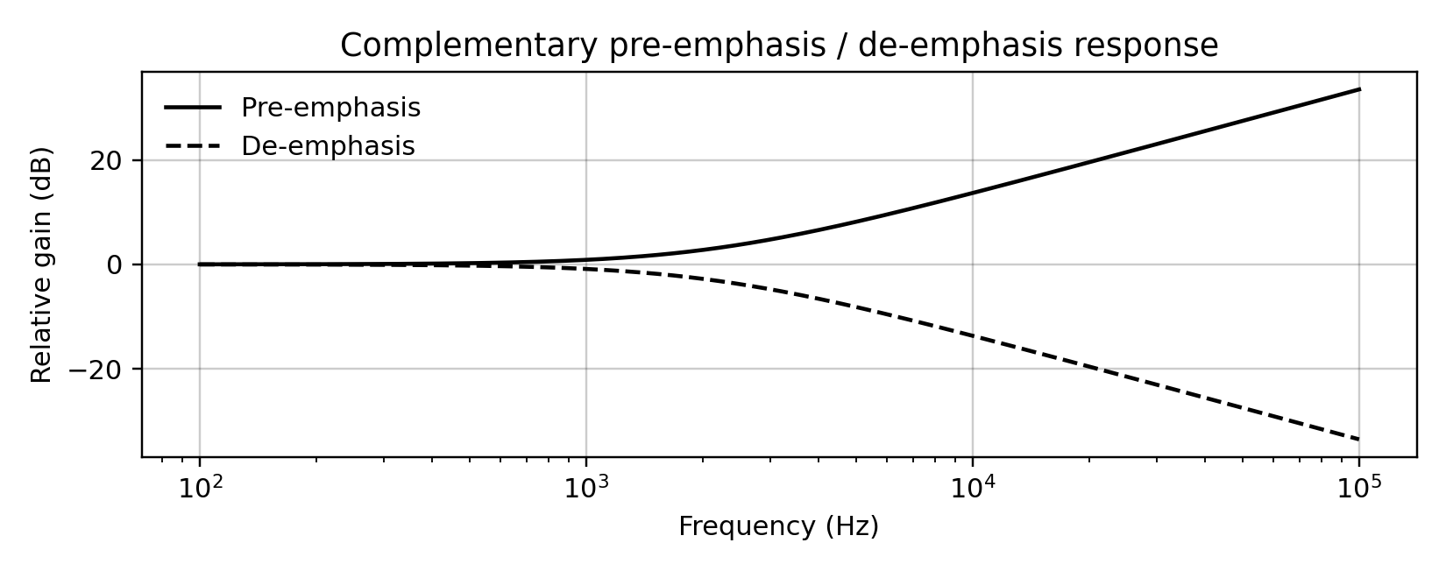
Figure 7. Illustrative complementary emphasis responses using a 75 μs time constant.
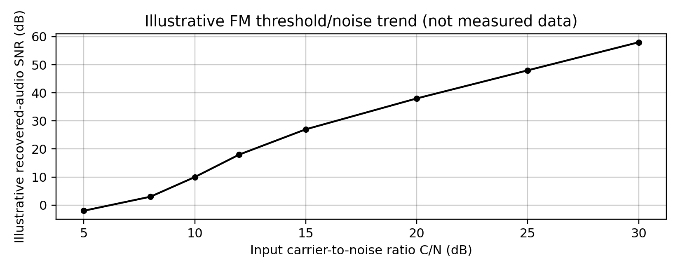
Figure 8. Conceptual FM threshold/noise trend. Values are illustrative only, not measured or simulated receiver data.
Operating recommendation: maintain adequate C/N across the intended service area, verify receiver performance near the threshold, and use matched pre-emphasis/de-emphasis. A precise minimum C/N cannot be specified from the brief because the required recovered-audio SNR and actual receiver characteristics are not supplied.

8. MATLAB-BASED VERIFICATION PLAN
The following steps can be implemented in MATLAB to verify the design: (1) generate a 15 kHz-limited audio message; (2) generate FM and PM waveforms; (3) inspect time-domain signals and magnitude spectra; (4) estimate occupied bandwidth and compare it with Carson’s rule; (5) add AWGN at several C/N levels; (6) demodulate FM and compare recovered audio; (7) plot recovered-audio SNR versus C/N to identify threshold behaviour; and (8) apply matched pre-emphasis and de-emphasis and compare audio noise.
A simulation should record its sample rate, message amplitude, deviation, carrier, noise definition, filter coefficients and demodulator settings. The figures in this report are explanatory illustrations generated for the report; they should not be described as measured hardware results or as output from a MATLAB run.

9. FINAL SPECIFICATION VERIFICATION
Requirement | Specified | Design value / status | Verification
Message bandwidth | 15 kHz | 15 kHz maximum | Set by audio low-pass filter
Carrier frequency | 100 MHz | 100 MHz candidate | Requires oscillator/frequency check
Peak deviation | 75 kHz initial | 75 kHz assumed | Verify with FM modulator
FM index | Calculate | 5 at 15 kHz | 75/15 = 5
FM bandwidth | Calculate | 180 kHz by Carson’s rule | Estimate; check regulations
Channel noise | AWGN + interference | Model in simulation | Requires C/N sweep
Pre/de-emphasis | Evaluate | Matched pair recommended | Verify audio response and standard
Receiver | Limiter + discriminator | Superheterodyne functional chain | Check sensitivity/selectivity/fidelity
MATLAB verification | Required | Plan described | Run with documented parameters before deployment

10. FINAL ENGINEERING DECISION
Decision: YES, conditionally, the FM broadcast system is a suitable candidate for deployment after compliance and performance tests. The initial design uses 100 MHz carrier frequency, 75 kHz peak deviation and a maximum message frequency of 15 kHz. These give β = 5 and an estimated Carson bandwidth of 180 kHz. FM is preferred over PM for this case because the specified receiver uses a limiter and frequency discriminator. Pre-emphasis/de-emphasis is recommended to improve recovered-audio noise performance, while AM and DSB-SC serve as reference systems for comparing detector requirements and power use.
Deployment must not be approved solely from the calculations in this report. The engineering team should confirm the permitted deviation and occupied bandwidth for the local channel plan, run MATLAB noise and threshold simulations, and test the actual transmitter and receiver across the coverage area. The final operating C/N and power cannot be fixed until an audio-quality target, receiver specifications and coverage requirement are defined.

REFERENCES
- ECA08 – Analog and Digital Communication, CO2 Case Study Assignment, supplied course brief.
- Carson’s rule for approximate FM transmission bandwidth: BT ≈ 2(Δf + fm).
- Standard communication-systems concepts for angle modulation, Bessel sidebands, AWGN, coherent detection and pre-emphasis/de-emphasis. Verify applicable broadcast regulatory requirements before implementation.

